Milestone 1: Forum

* Functionality:
  + Right now onRefreshing the list, the activity indicator never goes away. It should go away when it is done refreshing. Also, when the list is empty, there should not be an activity indicator. Maybe a list empty message/component instead.
  + Also the list continues to add the same questions onRefresh
  + **Answers with higher upvotes should be loaded first.**
* UI:
  + Post Question Component: Right now, the postQuestion component is a clunky modal with a textInput and some buttons. I just want it to more resemble the medium postQuestion component. You should be able to change text size, add bullet points, indent, etc. There is an open source react-native twitter clone project, you might be able to copy/paste code from their post component.

https://github.com/pranit123/Twitter-Clone

* + 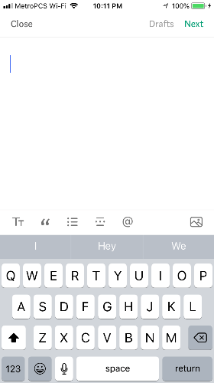
  + AnswerBlock: Right now it is a clunky block component. But it should be a read more block. If the user clicks read more, they should be navigated to a screen where the entire answer can be viewed.

<https://github.com/expo/react-native-read-more-text> <-- read more

* + AnswerScreen: You probably have to add another screen to the stack navigator. But once the user clicks readmore, they should be navigated to a screen where the entire answer is displayed. Should look like quora answer component. The question should be displayed at the top, then the author, and the answer underneath. **The upvotes/downvotes should be on this screen.**

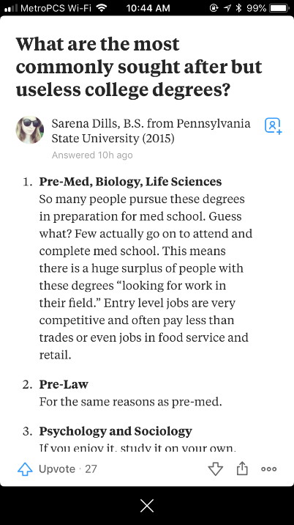

* + QuestionBlock: Right now the question blocks are clunky. They should more resemble the quora question components. There should just be the question, the topic, and the author/author profile picture. This picture below shows questionBlocks. I want something similar without the answer showing.

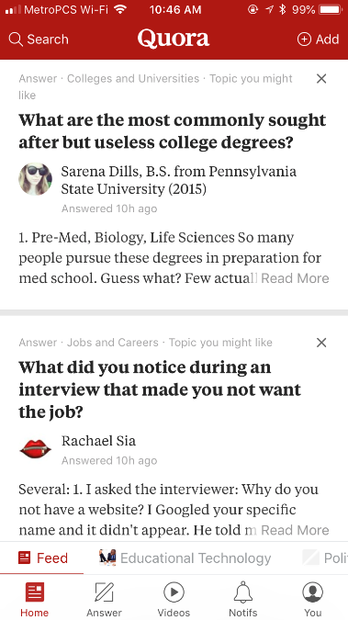

Milestone 3:UI/Debugging

* Logging Out
  + Logging out should change their portal. Like if one user (consultant) logs out, it should log them out of the entire app. If another user (student) then logs in, the student should see the student portal UI. Right now it would still show the consultant UI. A navigator component might have to be created, unless you can figure out how to pass the App.Js state into the selectPortalScreen as a prop.
* Calendar
  + Also a consultant shouldn’t be able to set availability on a date that has already passed, and a student shouldn’t be able to book an appointment on a date that has already passed. In firebase, it should be removed from the consultant availability once the data passes.
* Login/Sign Up:
  + The form slides up weird when signing up. Like when you click into a text box on the sign up form, the form slides all the way to the top of the modal. This shouldn’t happen.
* Ios vs Android
  + Making sure everything works/looks good and consistent on IOS and Android
* Find a Consultant
  + The consultantBlock/saleBlock should be cleaner. The picture should cover the card and maintain its aspect ratio, but it shouldn’t be as large and clunky as it is now.
* Select Portal Screen
  + The UI should be better. Right now it is just buttons, but it should be a generally cleaner and more appealing look.
* General UI
  + The purple right now is aggressive. It should be a lighter purple.

Bonus

* Decompose the app (utilize the metrics file, break files into components, essentially clean up the code)
* Implement Redux throughout the app

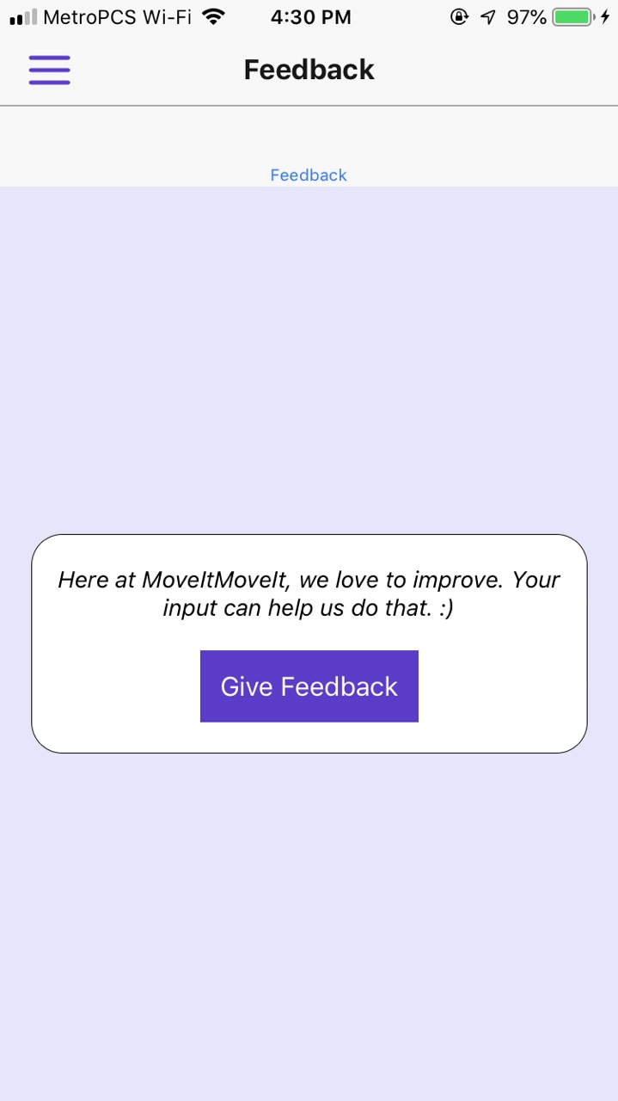

For the feedback screen i want the background color to be white, the box to have a purple outline. I like the purple u use, but if u can increase the transparency on it thtd b great. Right now its harsh. Still purple theme, but more white than purple

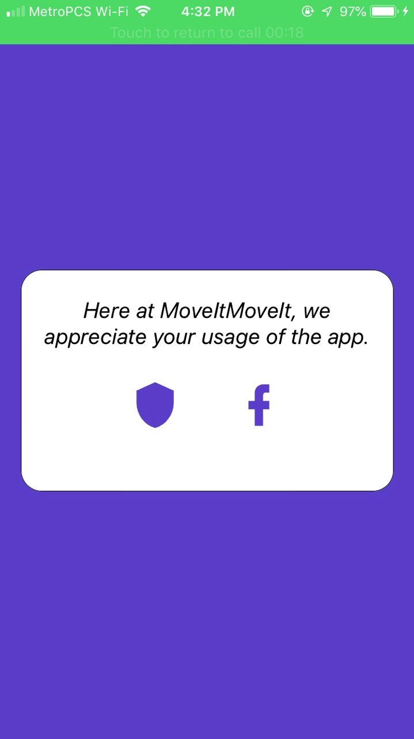

For this, white background, purple outline on box, purple icons, and a drawer nav button.

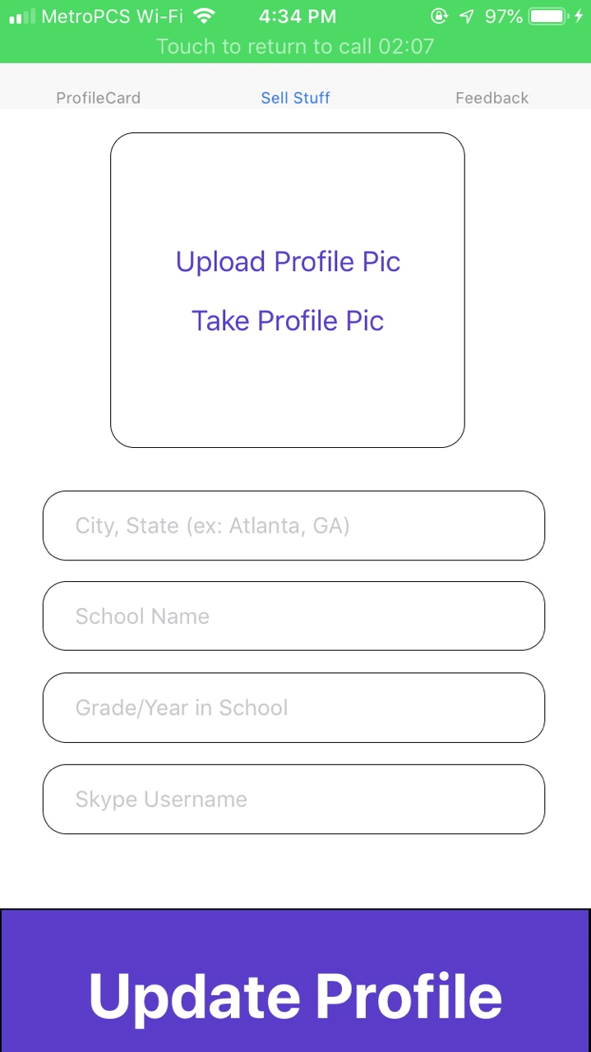

For this, purple outlines. More transparency in the purple.

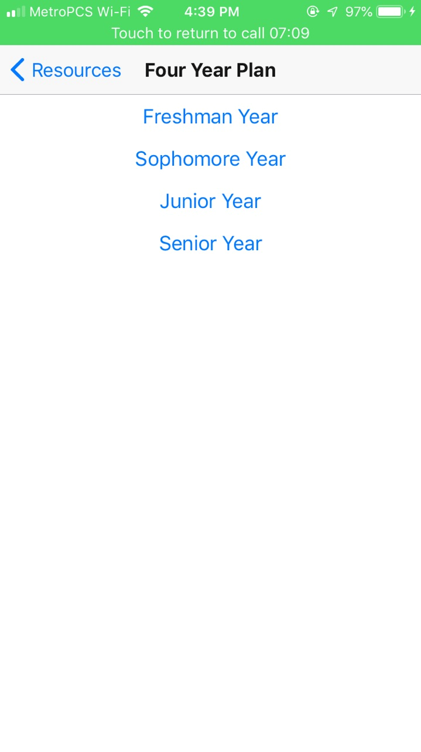

Should be purple themed. This page is ugly right now, these buttons should just look generally better. Better spacing, just look better

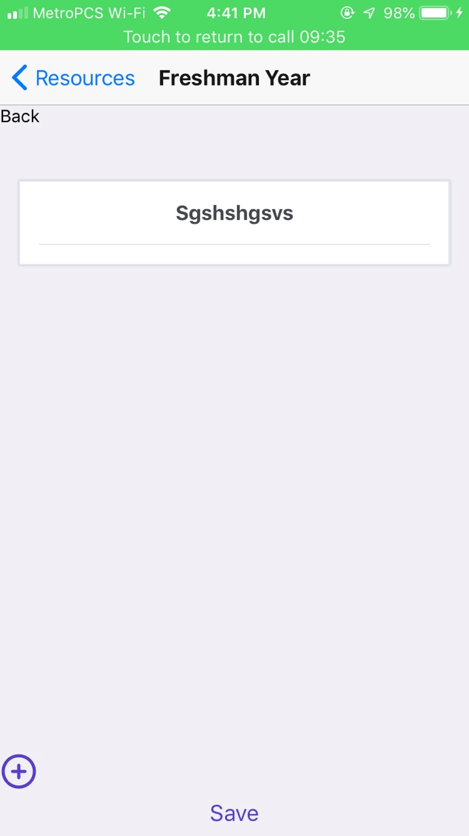

This page should look better. The save button should be better positioned. The add button be better positioned.

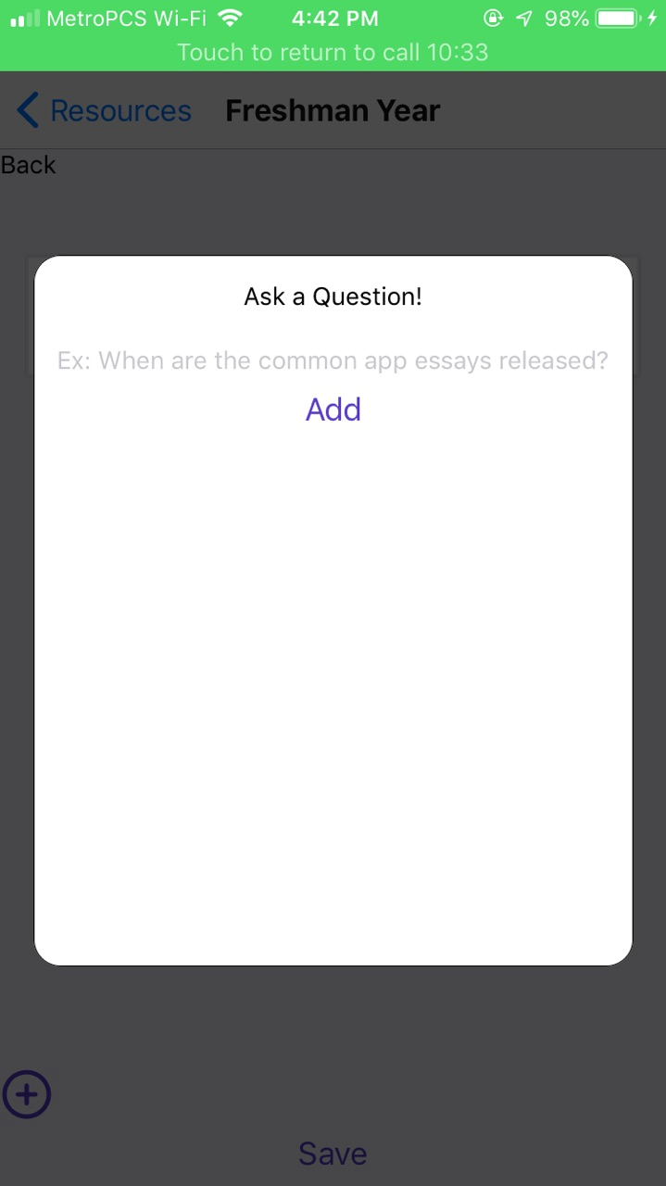

This modal should be better. The add button should be better positioned. Essentially all of the things in resources should look better.

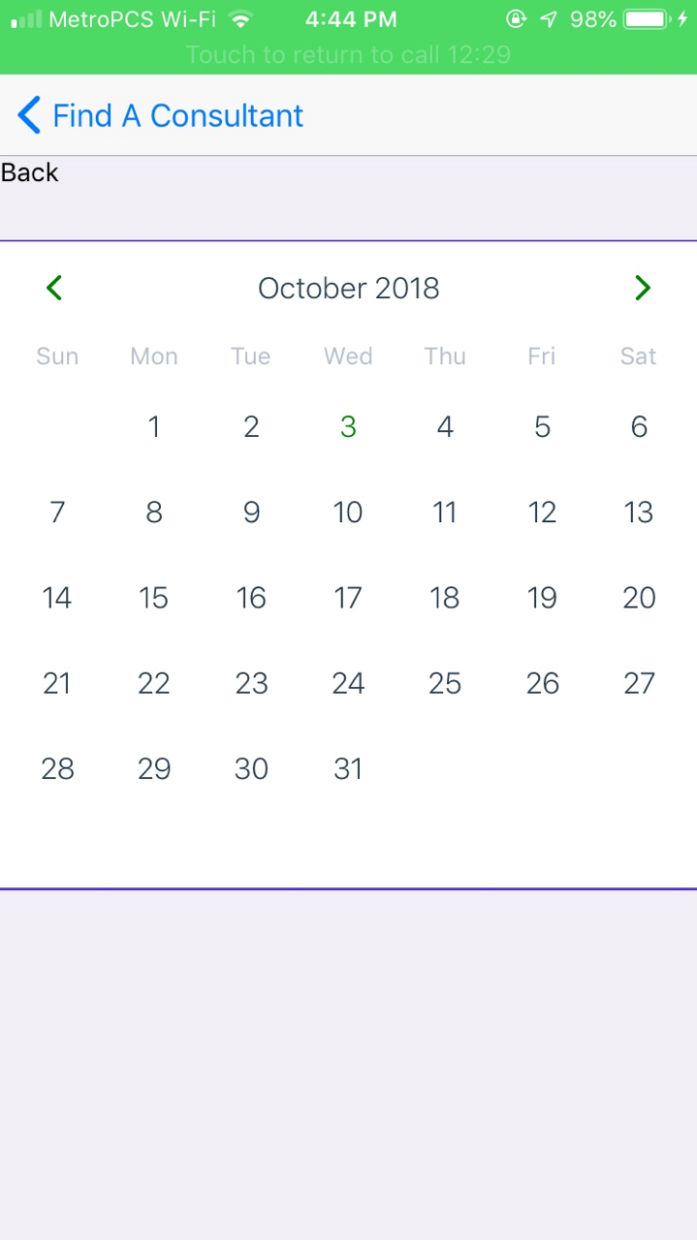

The back button should be purple. The calendar should be spaced better

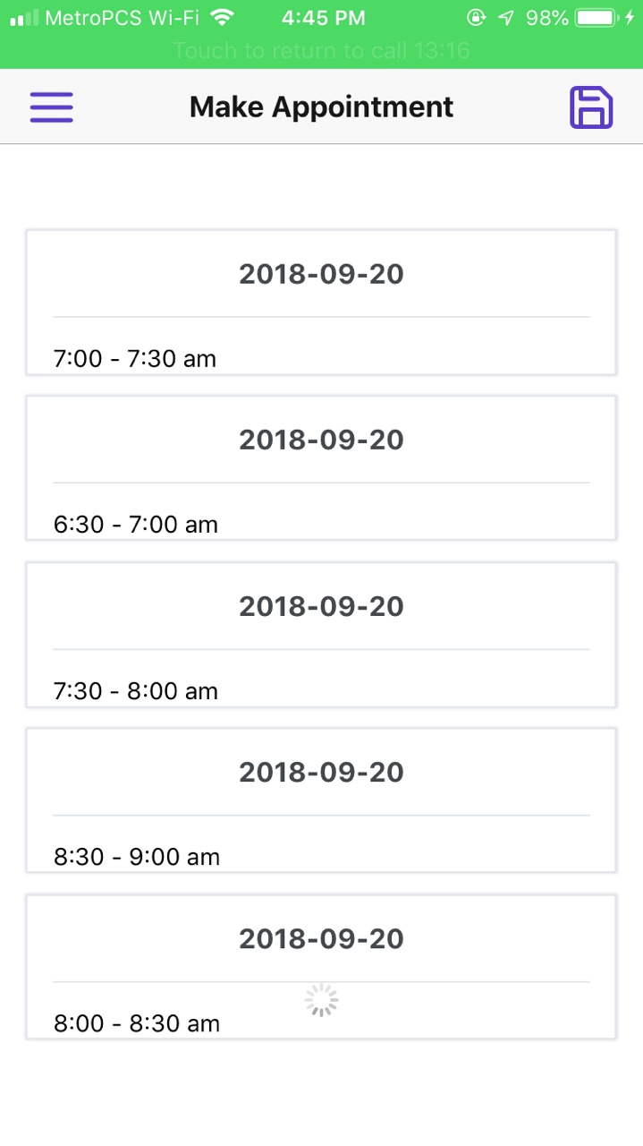

This activity indicator at the bottom shouldn’t load when the list is complete. Screen should look better

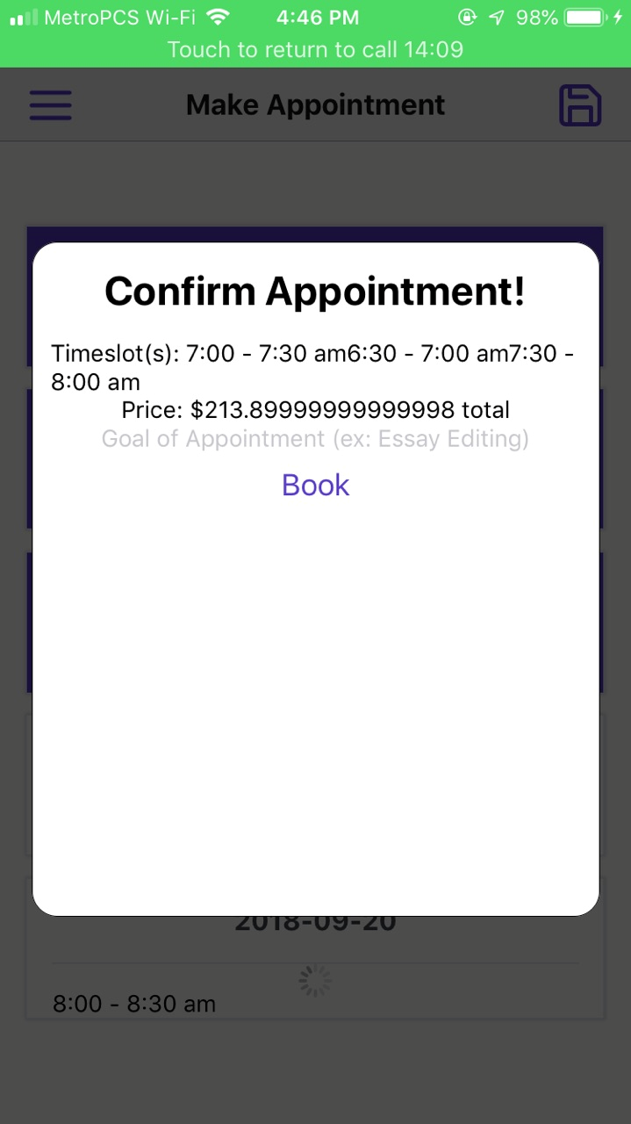

This modal should be spaced better. There should be spaces and commas for the timeslot array, the price should stop at the second decimal.